Focused Movement | Press Release
Exhibition date：2018/08/18 - 9/29  Exhibition venue：双方藝廊Double Square Gallery  Opening：2018/08/18 15:00  Participating artists：Liam Morgan, Wu Chi-Tsung, Yu Shih-Fu, Shyu Ruey-Shiann, Chen Shu-Chiang, Hsiao Sheng-Chien, Sunil Gawde  Curator：Michael Wu | 双方藝廊  Double Square Gallery  台灣台北市中山區北安路770巷28號  No.28, Lane 770, Beian Road, Taipei 104, Taiwan  TEL: +886 2 8501-2138 ext.33  週二至週日 10:30 – 18:30  Opening Hours: Tue – Sun 10:30 - 18:30  www.doublesquare.com.tw  媒體聯絡 Media contact：  Michael Wu 吳中平  michael@doublesquare.com.tw

Double Square Gallery is delighted to present the group exhibition, Focused Movement, from August 18 to September 29. The exhibition, curated by Michael Wu, features seven artists from Taiwan and abroad, including Liam Morgan (Canada), Wu Chi-Tsung, Yu Shih-Fu, Shyu Ruey-Shiann, Chen Shu-Chiang, Hsiao Sheng-Chien and Sunil Gawde (India). The artworks on view all demonstrate the element of mechanized movement and use mechanical components, in various artistic forms, such as dynamic machinery, sound, and light installation; these mechanized artworks reveal how the artists respond to the reality in a society characterized by digital technology.

Since the 60s, artists have been using camera, computer graphics, and interactive sensory technology more and more frequently, employing computer programs that made it relatively easier to control and manipulate these media while sometimes incorporating various portable electronic devices into the display of artworks. These new possibilities opened up a fresh space for creation, exhibition and the presence of artworks. Today, the perception offered by the virtual world has blurred the distinction between the real and the virtual, and art has gravitated towards virtual/augmented reality. The presence of artworks seems to be cross the boundary between reality and virtuality more freely. When new media art has made tremendous progress in the virtual realm, Focused Movement, on the other hand, features artworks that aim to lead viewers back to the physical world. By demonstrating the “substantial” spirit with a more elevated level of poetic expression in a semi-analogous way, the exhibition unveils the unique place held by new media art in the physical world. The technologies for observation and documentation have been progressing every day. The so-called new media that the public was familiar with in the past included a wide range of industrial materials, readymade objects, and computer software, which have already become classic in contemporary art along with the progress of technological development and the change of time. Undeniably, however, the combination of movements created by these material objects and the concepts illustrated by the artists continues to work in a dedicated and sincere manner, capturing audiences’ attention. In the exhibition, the artworks that make use of industrial, daily and natural objects are based on the artists’ personal cultural background as well as their contemplation on society, politics, environment and the self. In their individual ways, they use the materials and the means of sculpture and mechanized installation to express themselves or create an inner landscape that imitates nature, transforming the materials and giving them new meanings.

Sunil Gawde employs ordinary ready-mades, such as scissors, light bulbs or magnifying glasses, to create sculptures, paintings and mechanized installations. His methods amalgamate science and sensibility, transforming the nature of objects into metaphors. Liam Morgan creates installations that use “light” as a primary element. His different cultural and political experiences of living in Thailand create a unique narrative perspective in his work. Wu Chi-Tsung creates photography, video and installation. His work on view in the exhibition combines traditional aesthetics and modern/contemporary artistic languages, and uses a mechanical device to repeatedly adjust the focal length to transform a common piece of wire mesh into a moving image of a Chinese landscape. Yu Shih-Fu specializes in creating new media art that integrates mechanical installation, metal craft and dynamic structure. His works have been characterized as mixed media art and mechanical art, which unfold his personal life experience. Each installation created by Shyu Ruey-Shiann represents an experimental process building from zero. He employs the principle of dynamics, and infuses his work with the memory and care about life through his precise combination of mechanical components and the rhythm of repeated movements. Chen Shu-Chiang considers every natural object a symbol of the chaotic cosmos. His work reveals a spectrum of formal, aesthetic and spiritual possibilities of materials, creating a sense of visual tension. Recently, Hsiao Sheng-Chien prefers to adopt low-tech approaches to present the handmade aspect in technological art. Through creating natural landscape through artificial ways, he satirizes human being’s blind, insatiable pursuit of industrial and technological development at the expense of our precious natural environment.

Focused Movement is an aesthetic experiment originating from the collision between tradition and technology. It demonstrates how the seven artists have responded to the impacts from the rapid development of technological media; it also reflects the rich possibilities of expression that have unveiled by the physical world and have been overlooked in the pursuit of technological development today. As our definition of reality evolves, the exhibition is a collective statement of how artists re-evaluate the real world that they inhabit.
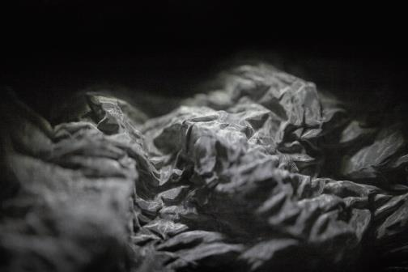 | 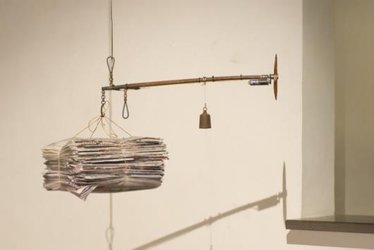
Wu Chi-Tsung, Wire V, 2018, Metal, glass, motor, Dimensions variable | Shyu Ruey-Shiann, Carrier No. 8, 2013, metal construction, metal, propeller, newspapers, antique scale and weights, 68x45x50 cm

